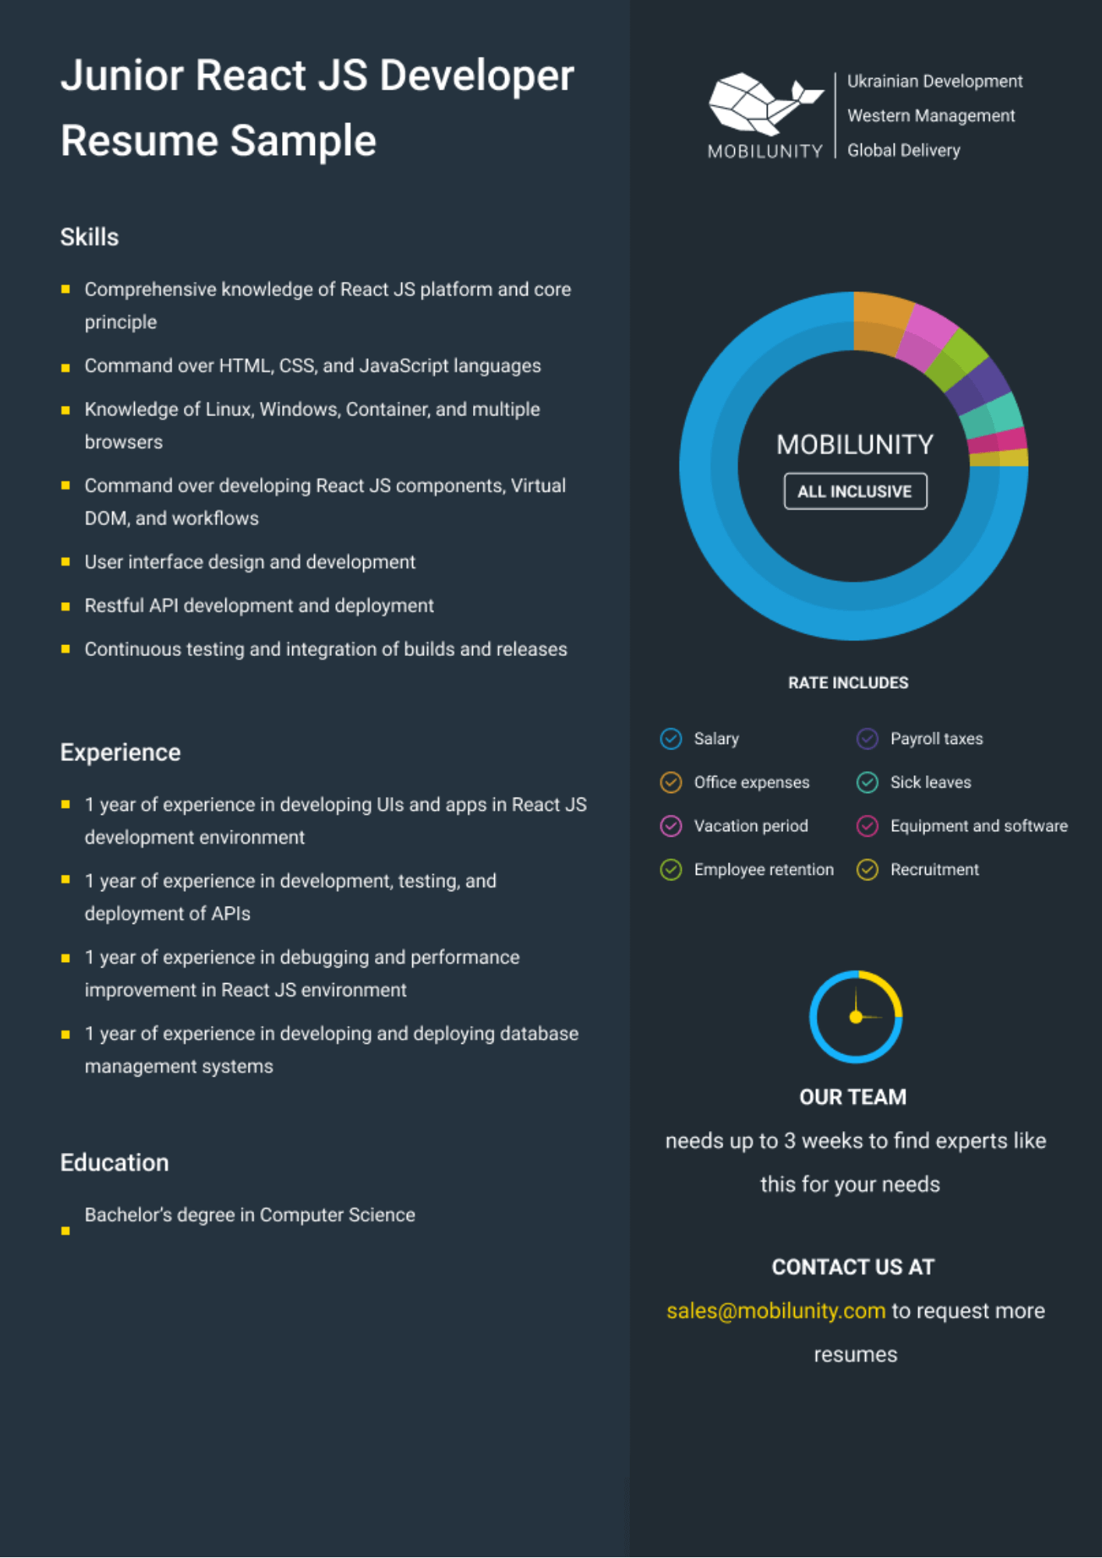
Junior React JS Developer Resume Sample
Ukrainian Development
Western Management
MOBILUNITY Global Delivery
Skills
■Comprehensive knowledge of React JS platform and core principle
■Command over HTML, CSS, and JavaScript languages
■ Knowledge of Linux, Windows, Container, and multiple browsers
■Command over developing React JS components, Virtual DOM, and workflows
User interface design and development
■ Restful API development and deployment
■Continuous testing and integration of builds and releases
MOBILUNITY
ALL INCLUSIVE
Experience
■ 1 year of experience in developing Uls and apps in React JS development environment
■ 1 year of experience in development, testing, and
deployment of APIs
■ 1 year of experience in debugging and performance improvement in React JS environment
■ 1 year of experience in developing and deploying database management systems
Education
Bachelor's degree in Computer Science
RATE INCLUDES
Salary
Office expenses
Vacation period
Payroll taxes
Sick leaves
Equipment and software
Employee retention
Recruitment
OUR TEAM
needs up to 3 weeks to find experts like
this for your needs
CONTACT US AT
sales@mobilunity.com to request more
resumes

